**Lab20**

**Cloud Formation – S3 bucket creation**

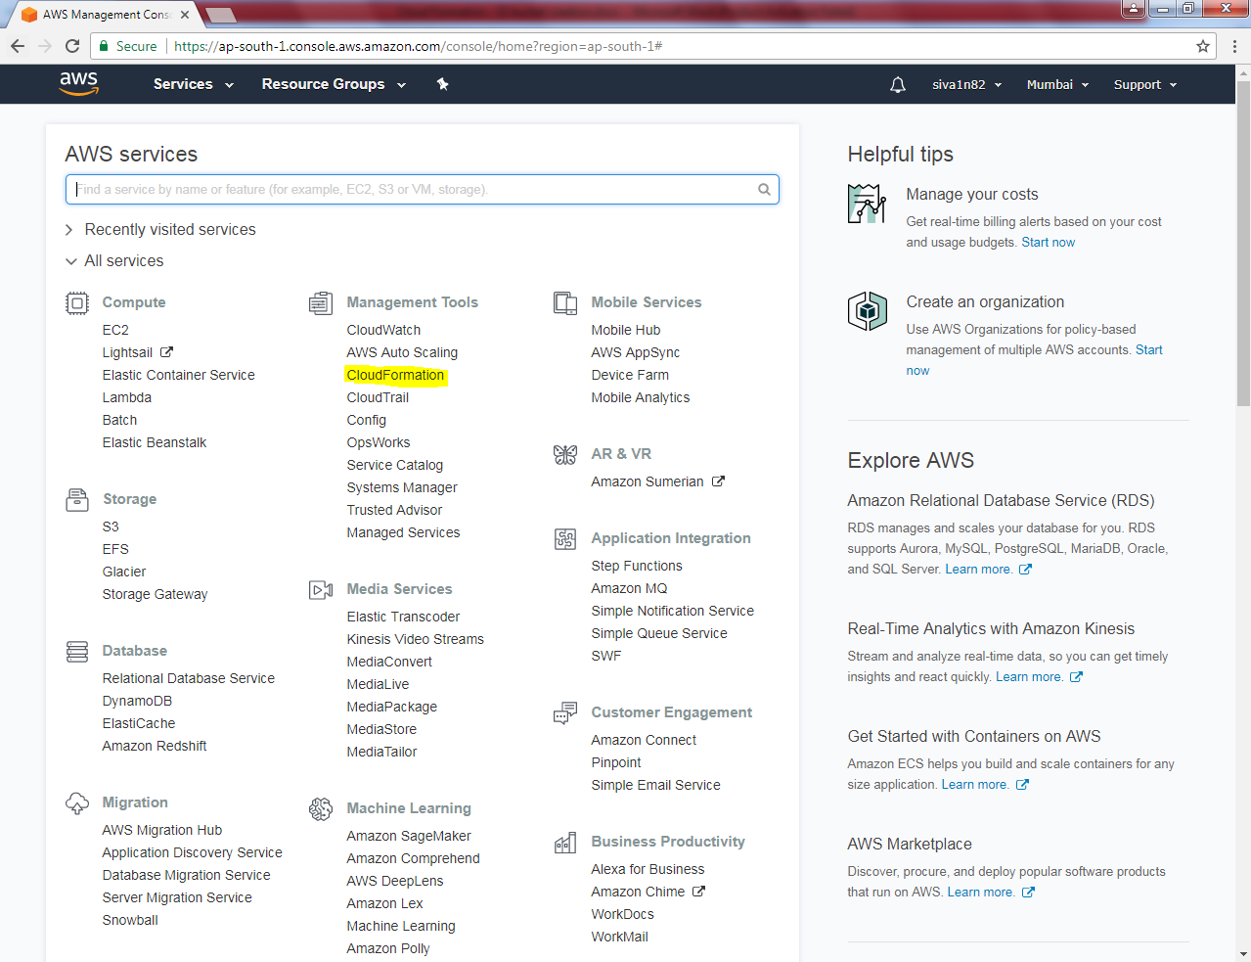

Click “Design template”.

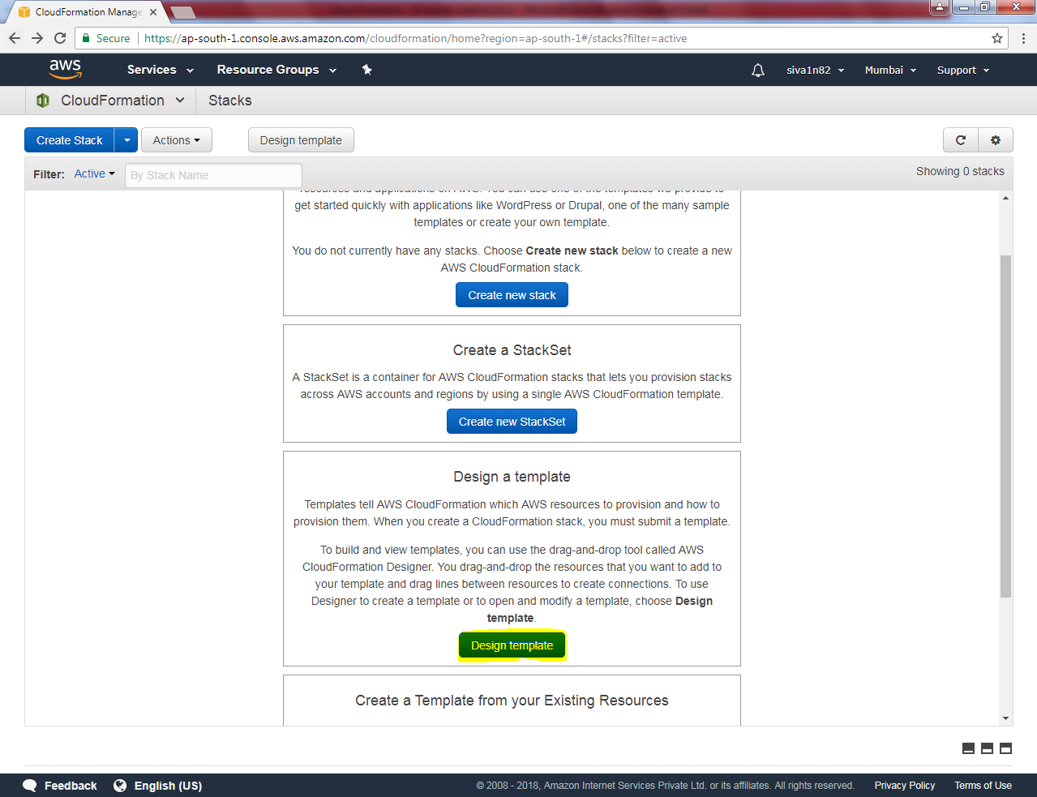

Select S3 and click “Bucket”.

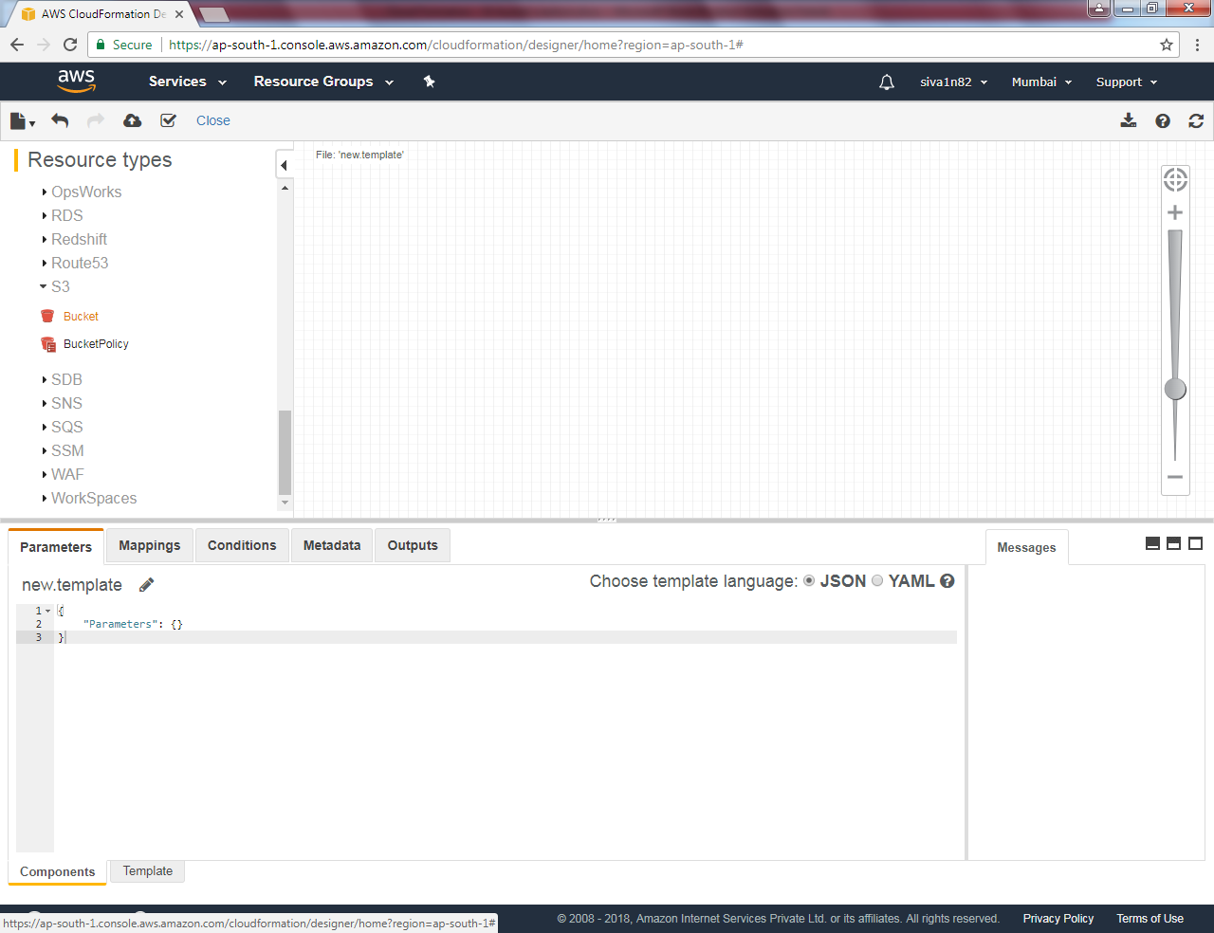

Drag bucket into designer.

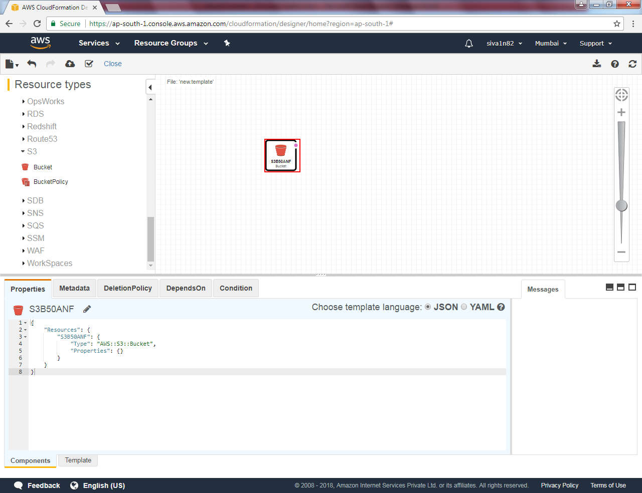

Click Bucket name and type new bucket name.

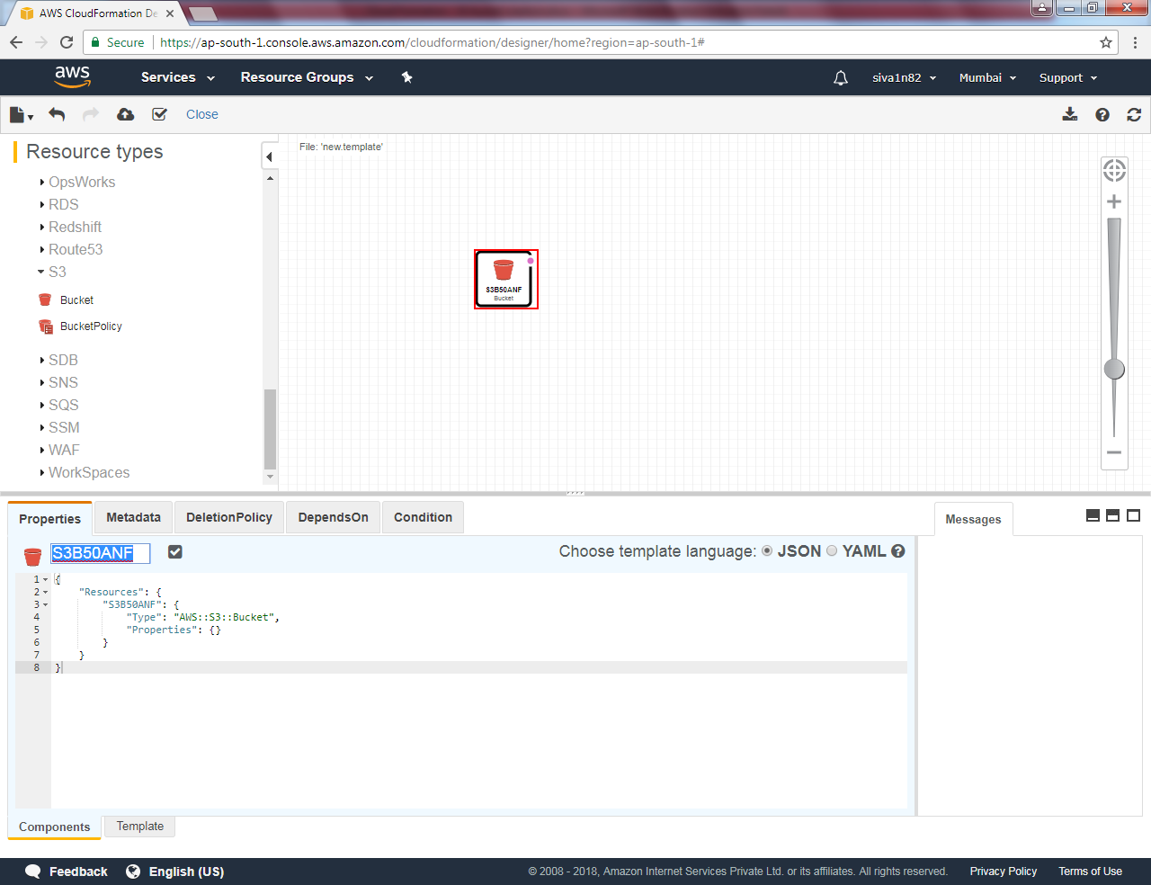

Type “ sansbound” Type bucket name and click Tick mark

Click Refresh to get effect with new bucket name

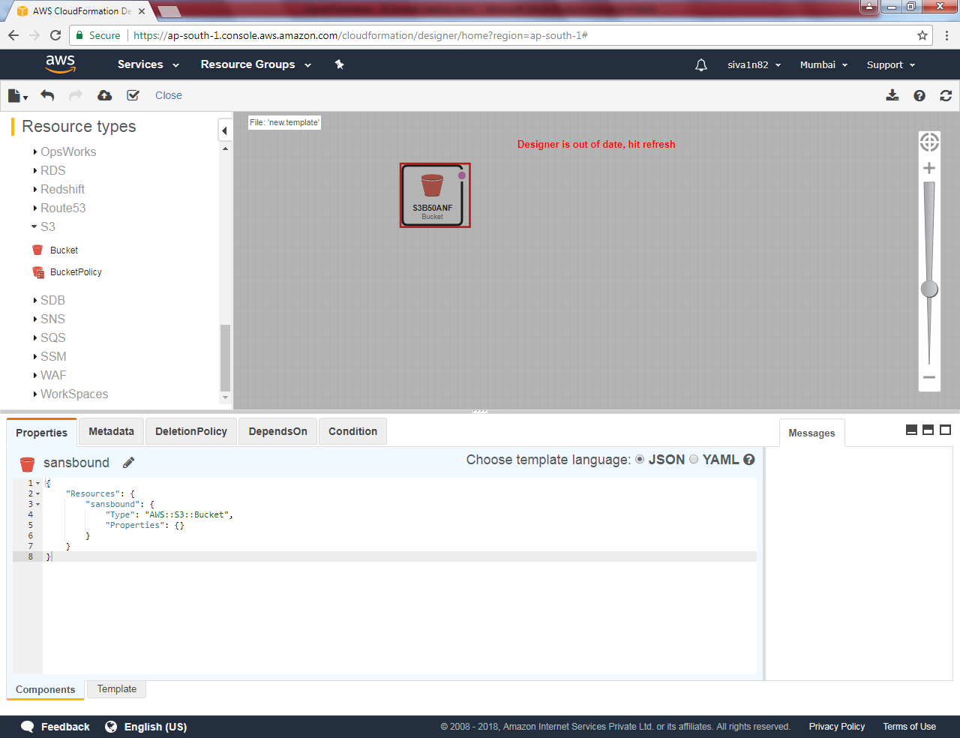

Now bucket name has renamed.

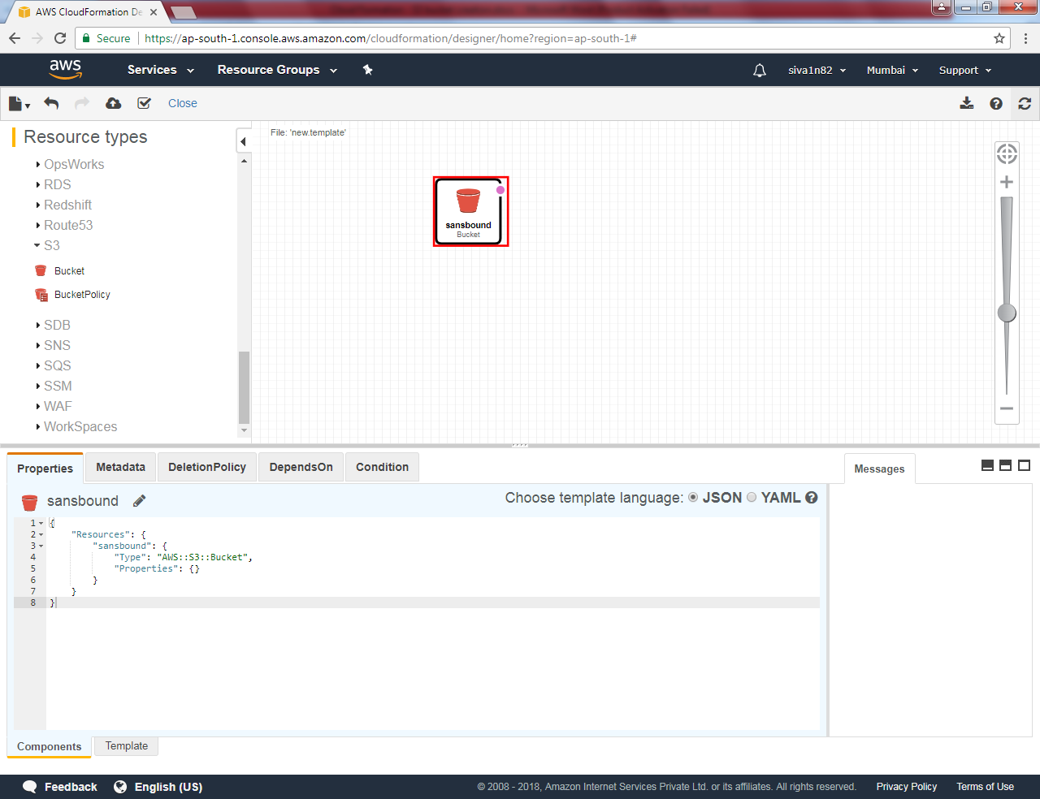

Click highlighted area (Create stack) to create the bucket.

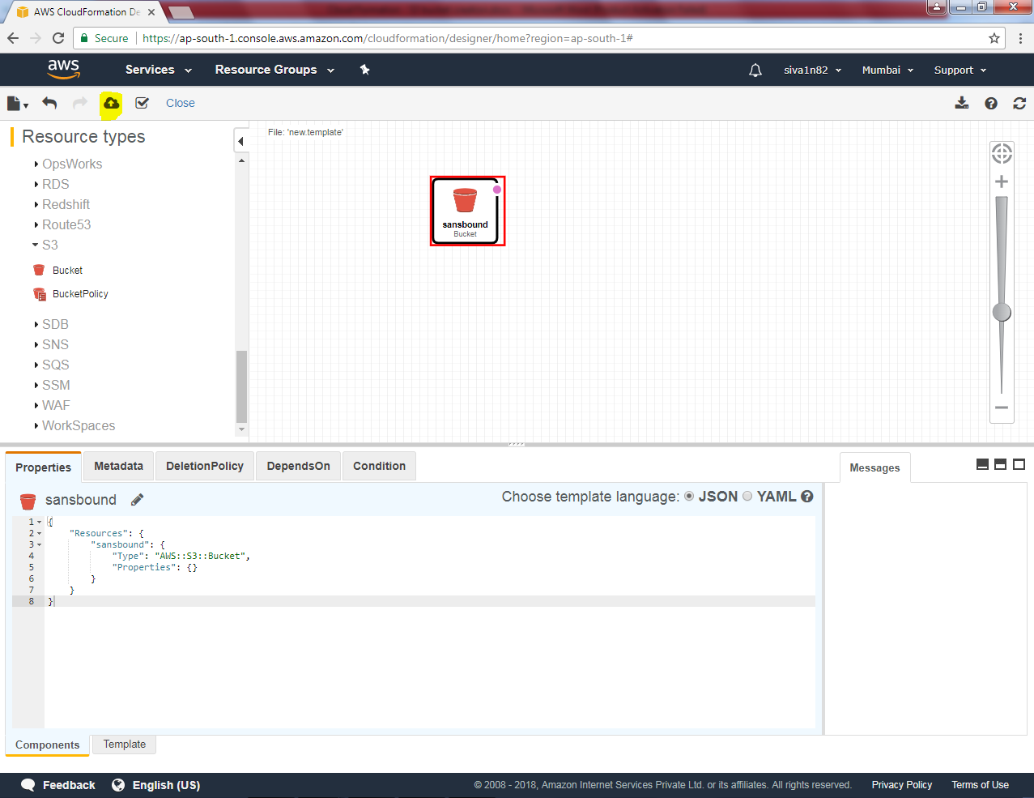

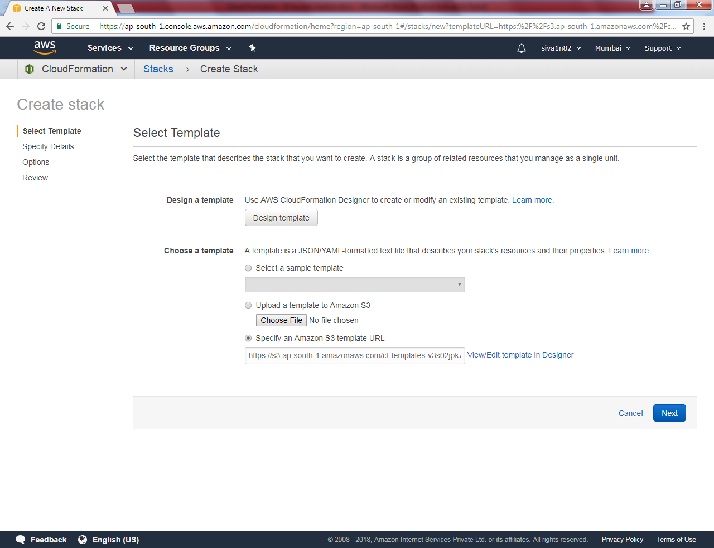

Type stack name as “s3bucket”

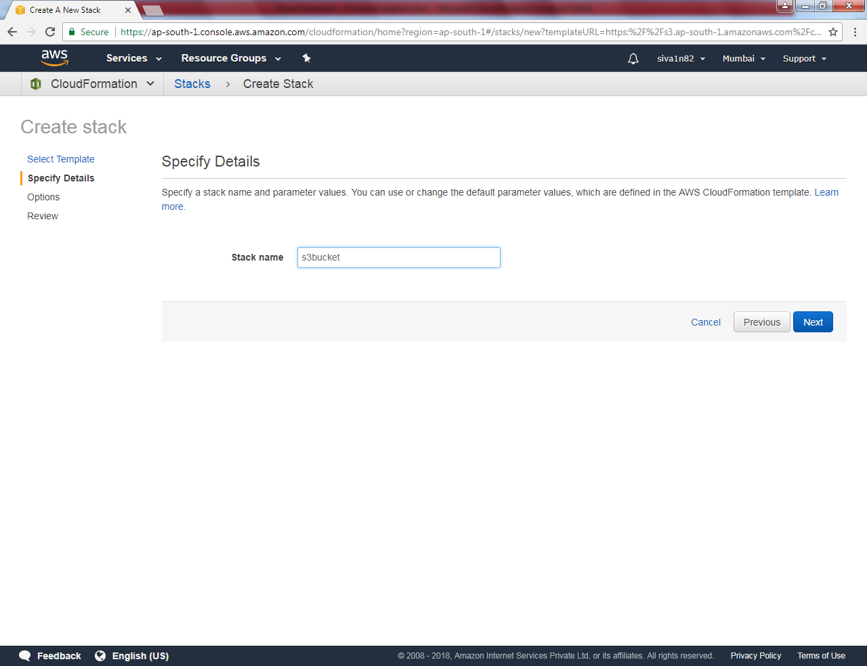

Leave default and click “Next”.

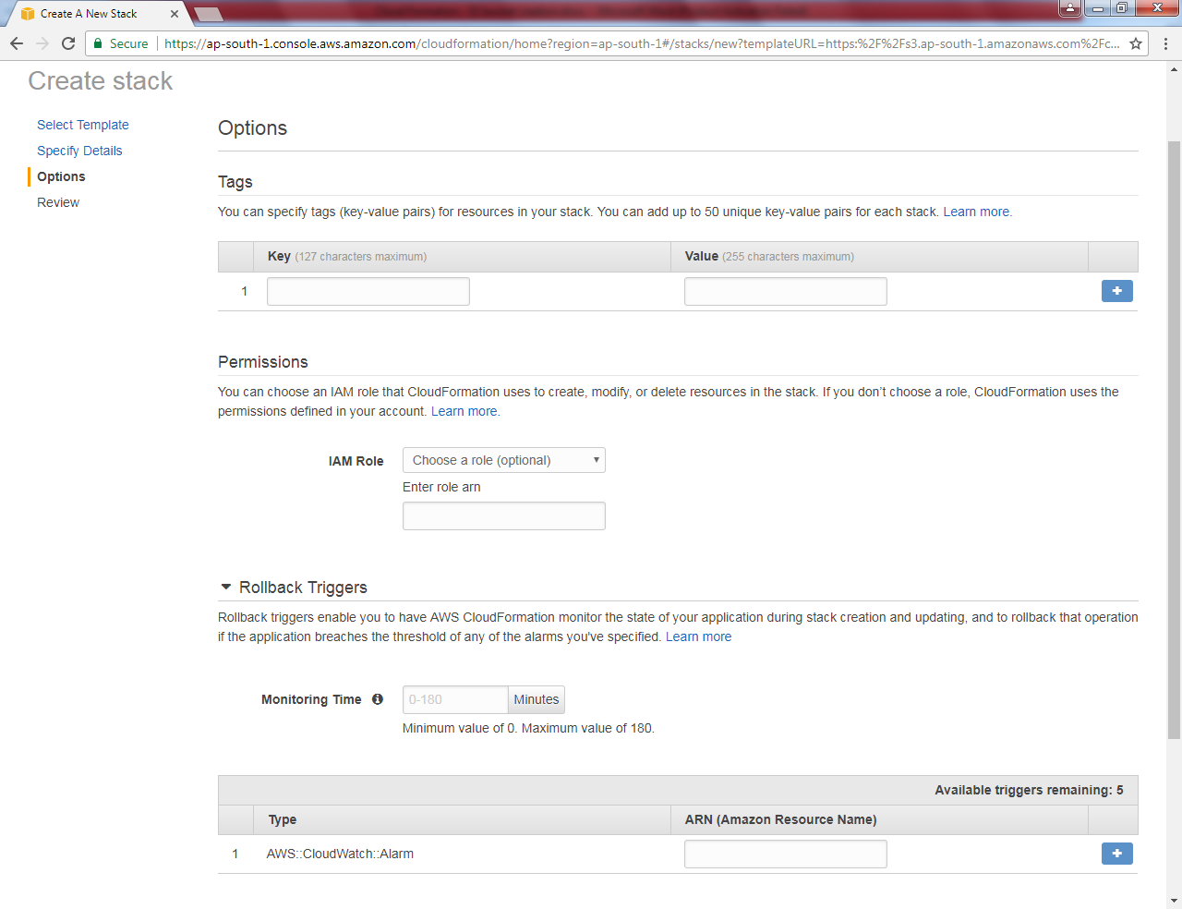

Click “Create”.

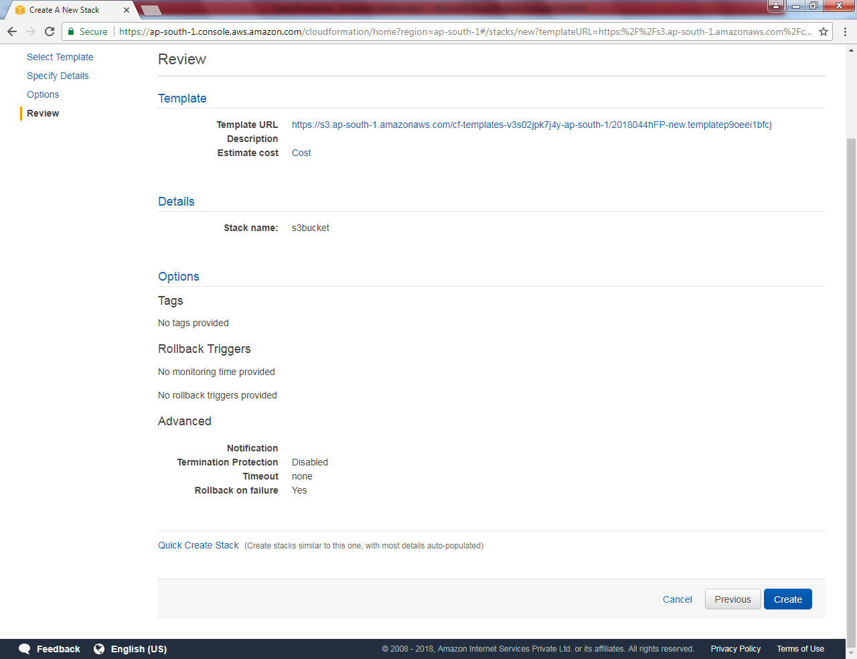

Press “F5”.

Again press “F5”.

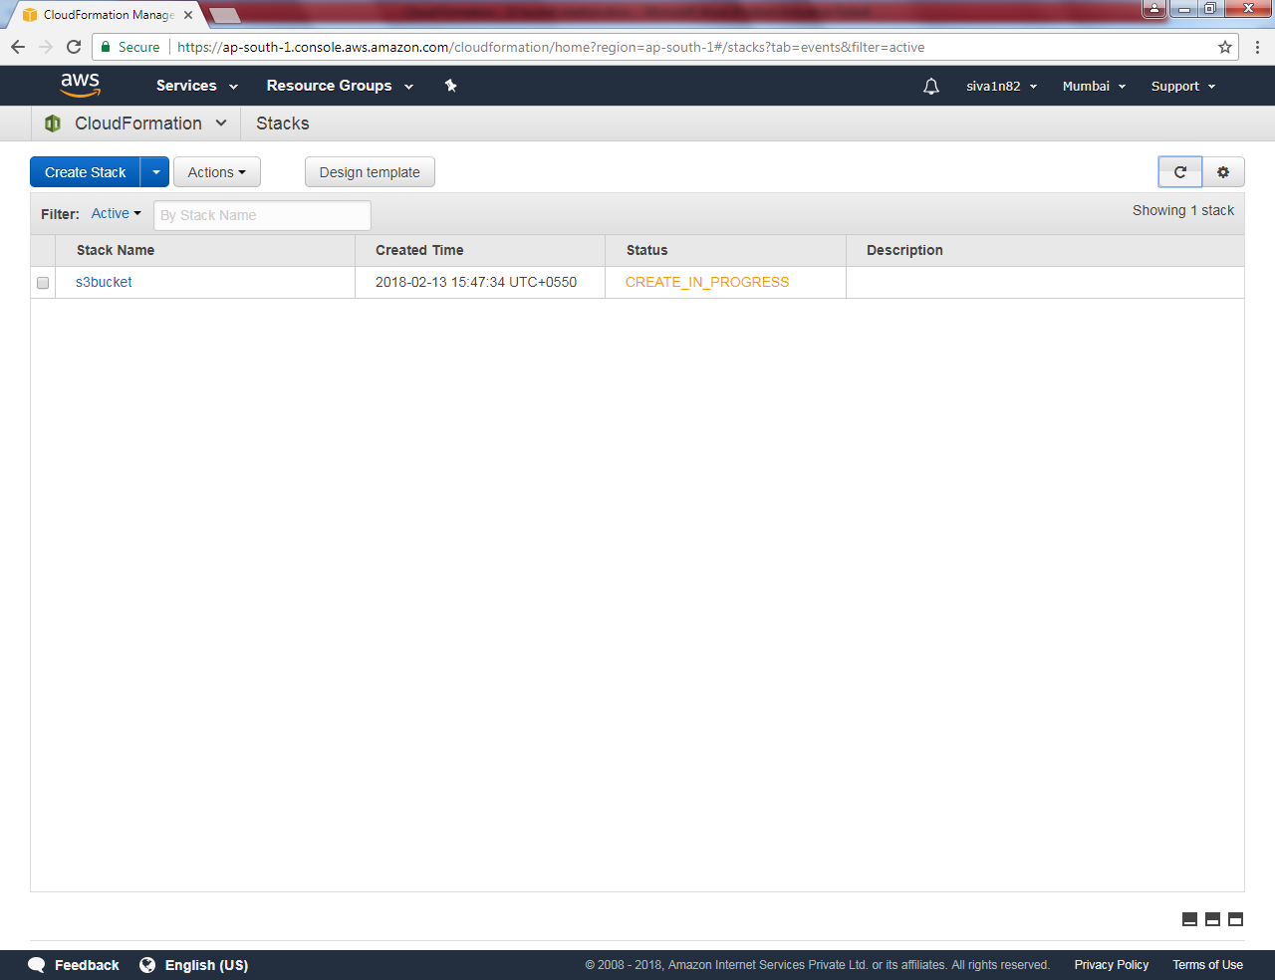

Now S3 bucket has been successfully created.

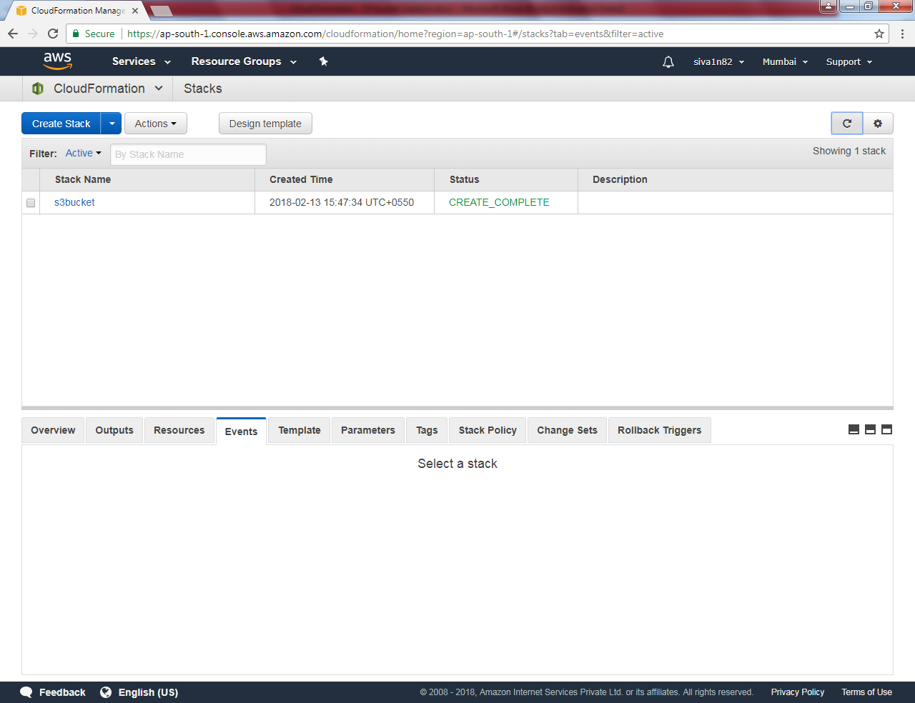

Go to S3, you can able to view the folder in the name of sansbound.

